Expected losses of GS-065-011-1-L

# Parameters:

* Parameters are worst case (above normal converter operating current)
* 4A, 390V (normal converter current 3A)
* Si8274GB1-IM1 gate drive (Ron = 2.7Ω, Roff = 1 Ω)
* Additional 15Ω on resistor and 2Ω off resistor
* Eoff = 2.5894µJ

# Turn off:

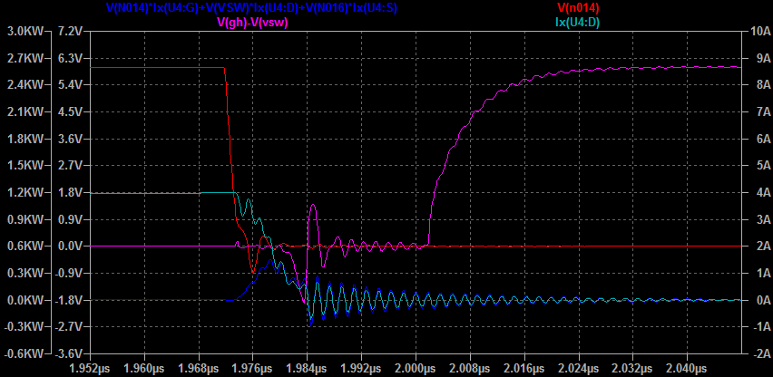

Blue = Instantaneous power dissipated in low side device  
Red = Low side gate voltage  
Cyan = Current low side drain  
Purple = High side gate voltage

2.5399µJ, turn off has caused 1.44V spike in high side gate voltage, undershoot is only to -0.9V, no overshoot on high side. High side turn on it not causing visible gate disturbance on low side.

Turn on: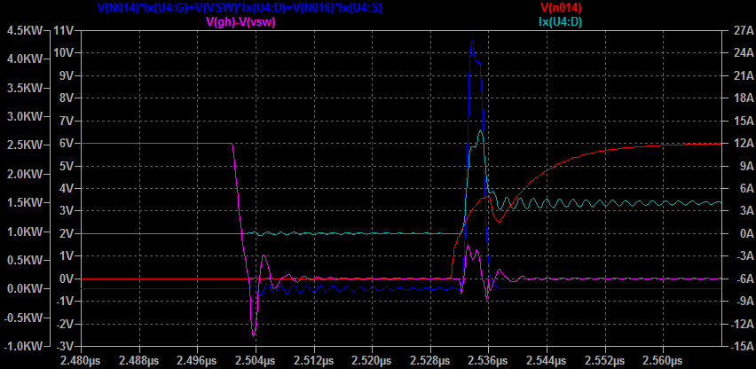

Blue = Instantaneous power dissipated in low side device  
Red = Low side gate voltage  
Cyan = Current low side drain  
Purple = High side gate voltage

10.346µJ, turn on has caused a 1.53V spike in the high side gate voltage this does not appear to be sufficient to cause excessive shoot through however as datasheet gives saturation Ids as ~3A for 2Vgs and no shoot through is observed in simulation.

# Summary:

Switching transients are very fast <10nS. It may be possible to turn on faster but this would probably bring risk of shoot through. Worst case device switching dissipation 2.58W per device @ 200 kHz, 4A. Worst case Rds = 0.38 Ω @ 4A, 125C resulting in 6W per device static dissipation. Total = 8.66W. Device will be cooled by reverse side direct heat sinking.

Thermal vias under the thermal pad are 0.3 mm diameter (12 mil) with 0.635 mm pitch (25 mil). Each via has a thermal resistance of ~261c/W (1oz) and we can fit ~30 under the device reducing this to 8.7c/W. There are other thermal considerations but this seems to indicate relatively conventional cooling will work.